API Testing Documentation

1. Swagger UI
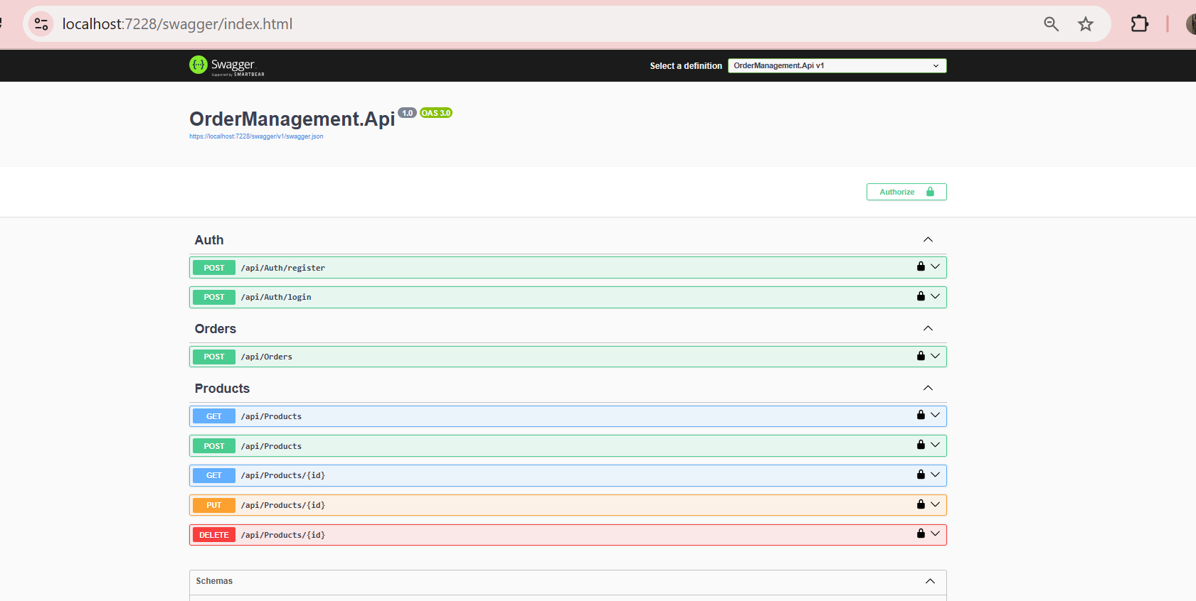

1.1 API Without Authorization Token 401 status code
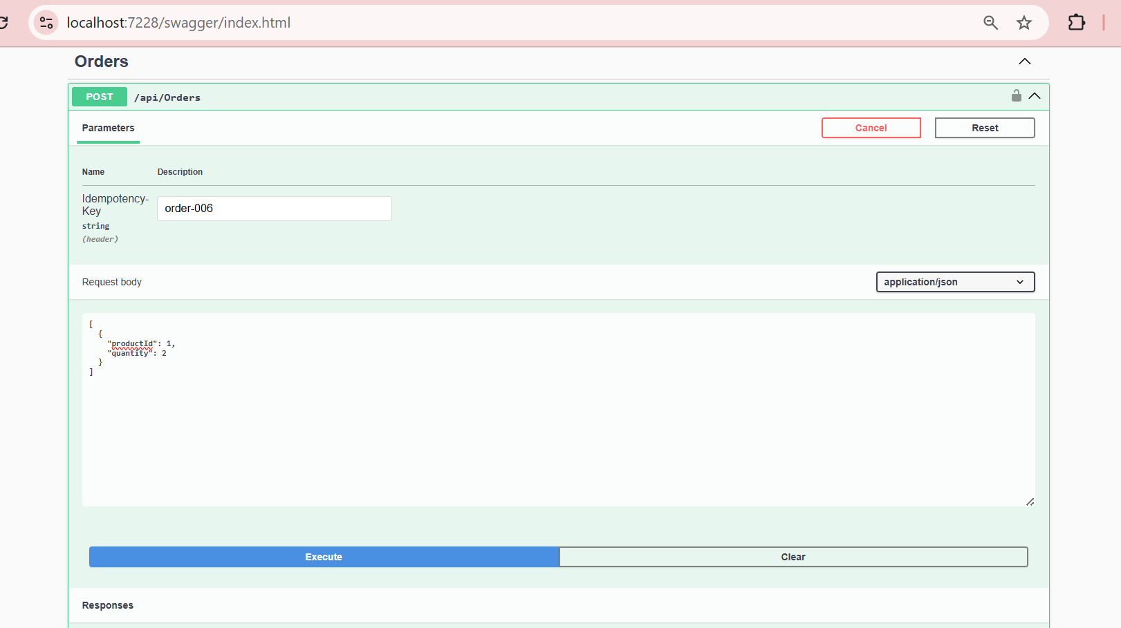

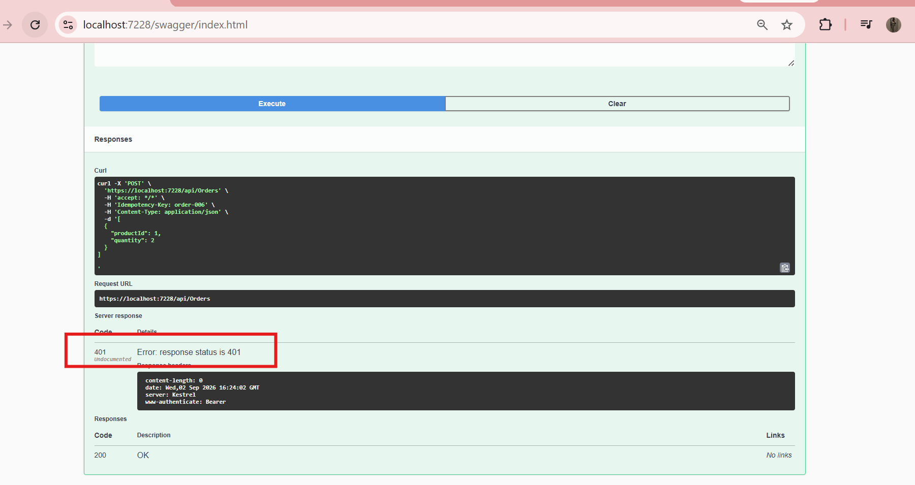

2. Authentication

2.1 Register User
Sample Request Body:
{
"username": "Priya",
"password": "Priya@24"
}

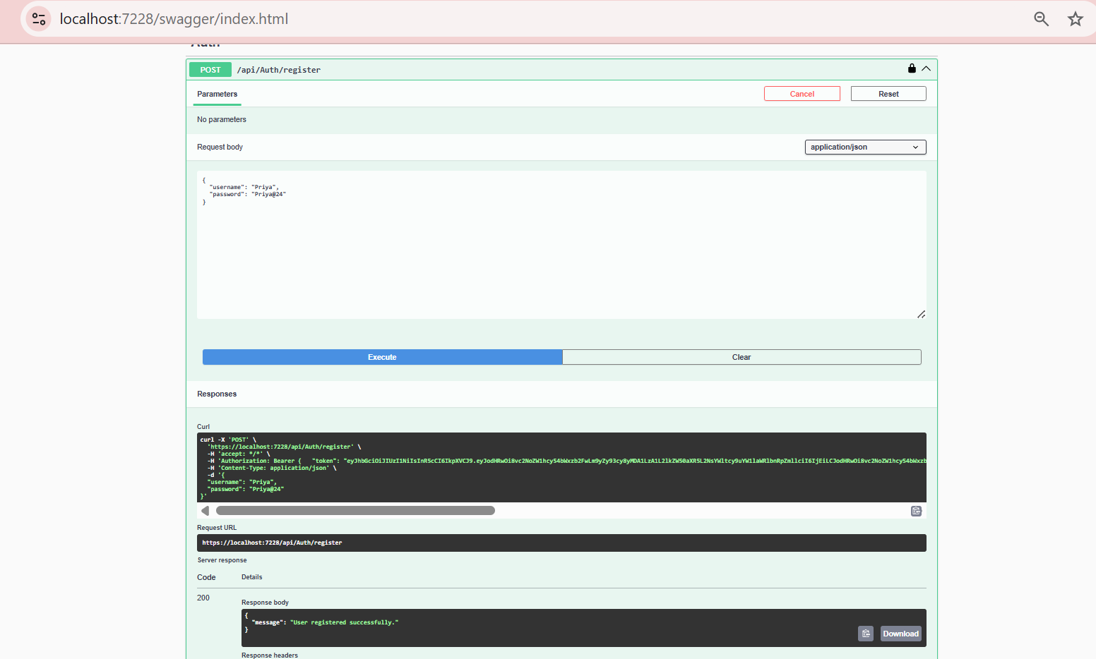

2.2 Login User
Sample Request Body:
{
"username": "admin",
"password": "admin123"
}

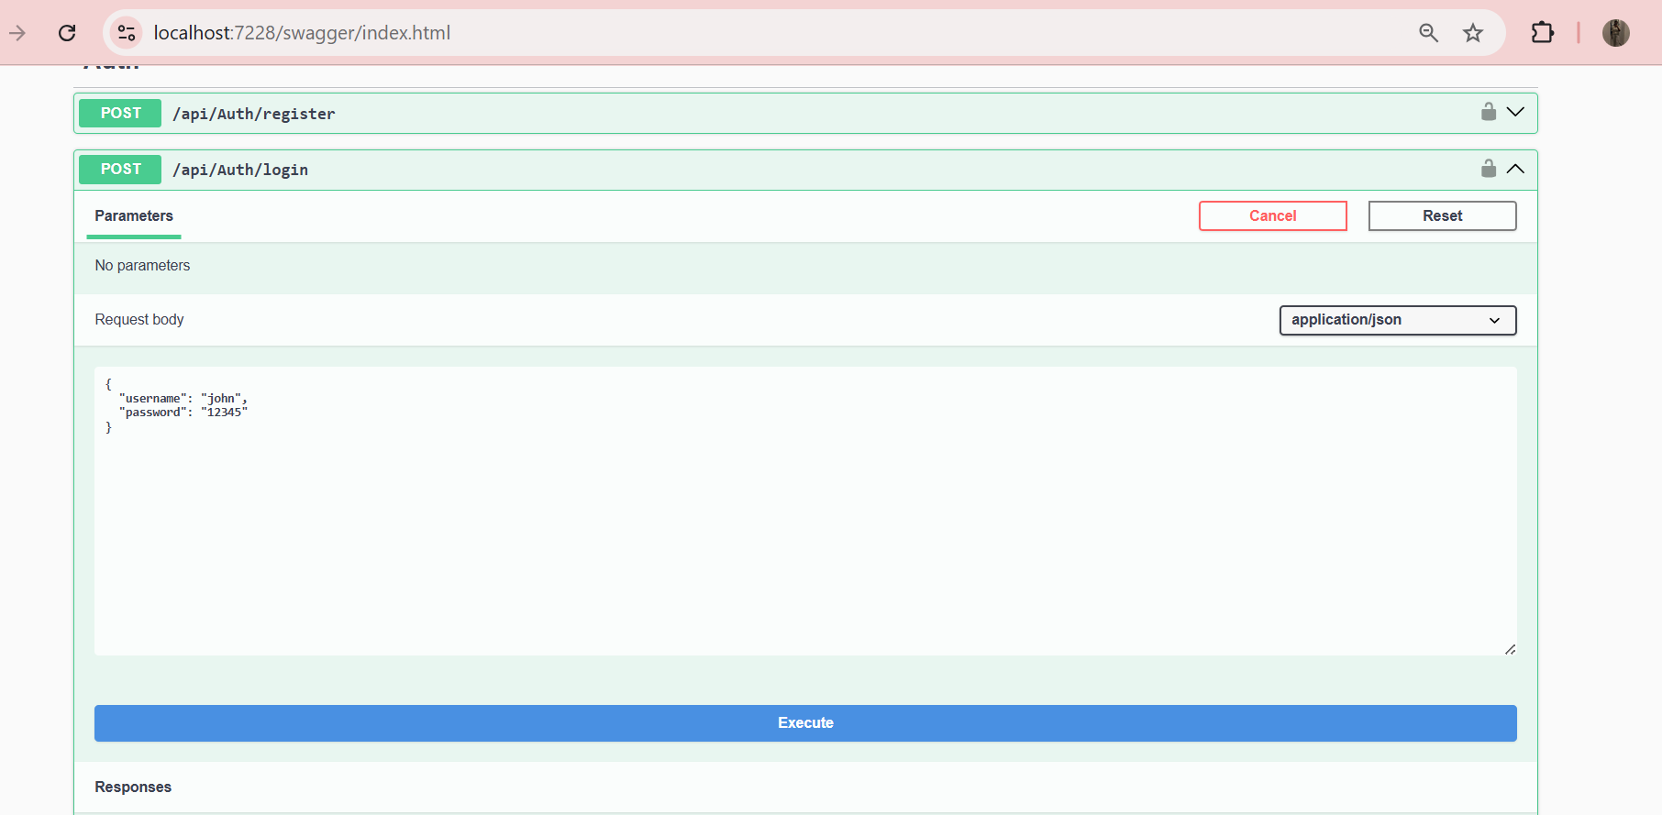

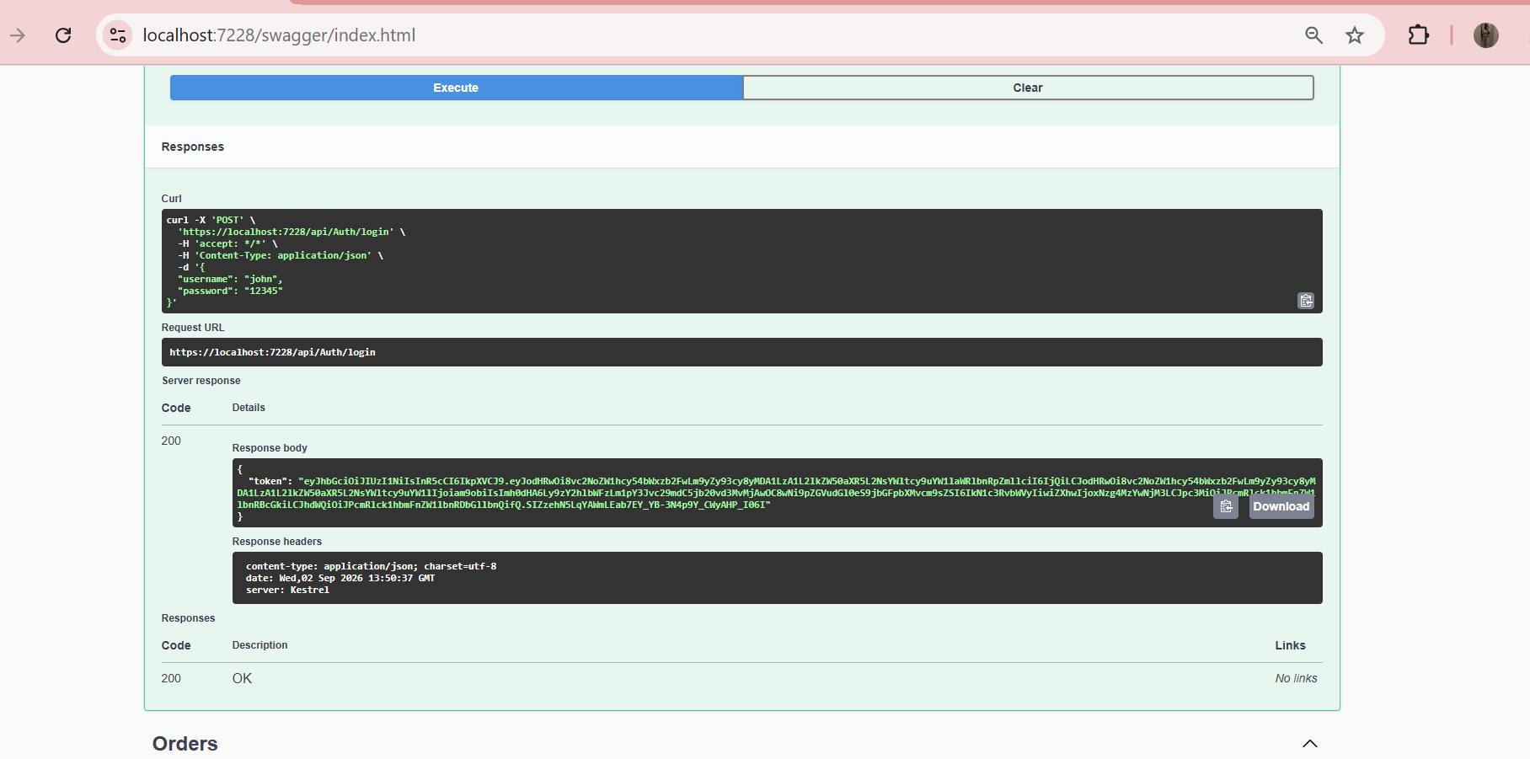

3. Product Management

3.1 Create Product
Sample Request Body:
{
"name": "Travel Bag",
"price": 1000,
"stockQuantity": 3
}

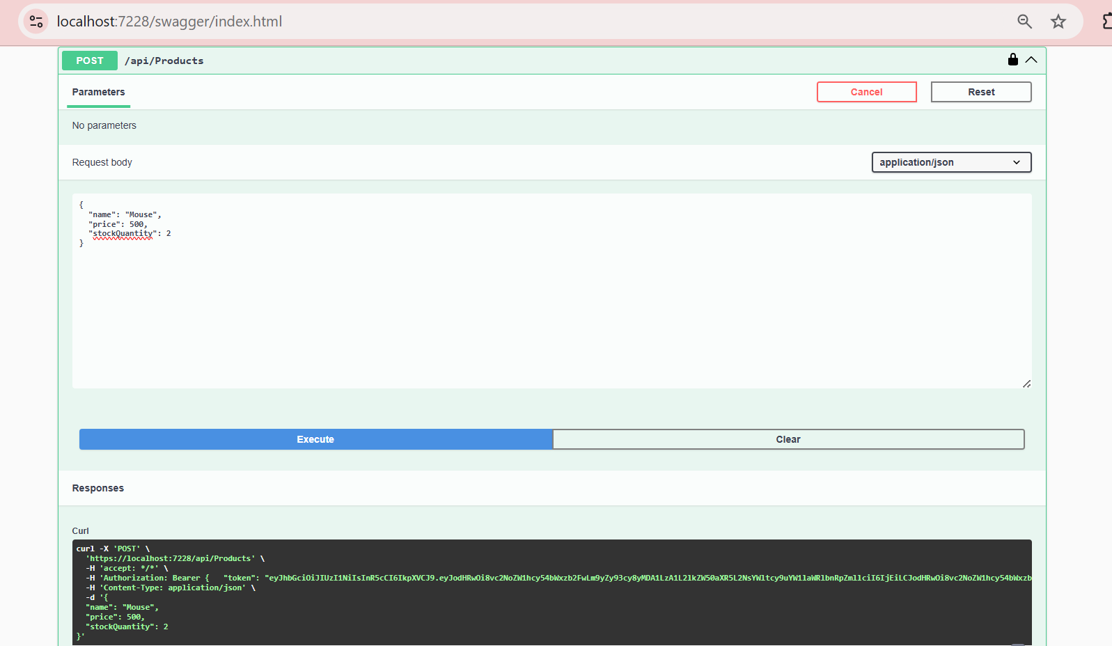

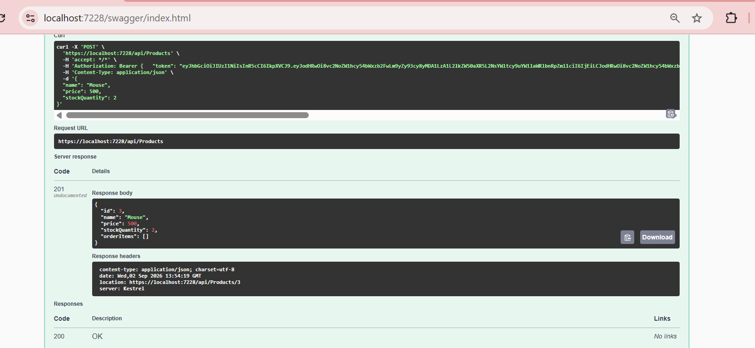

3.2 Get All Products
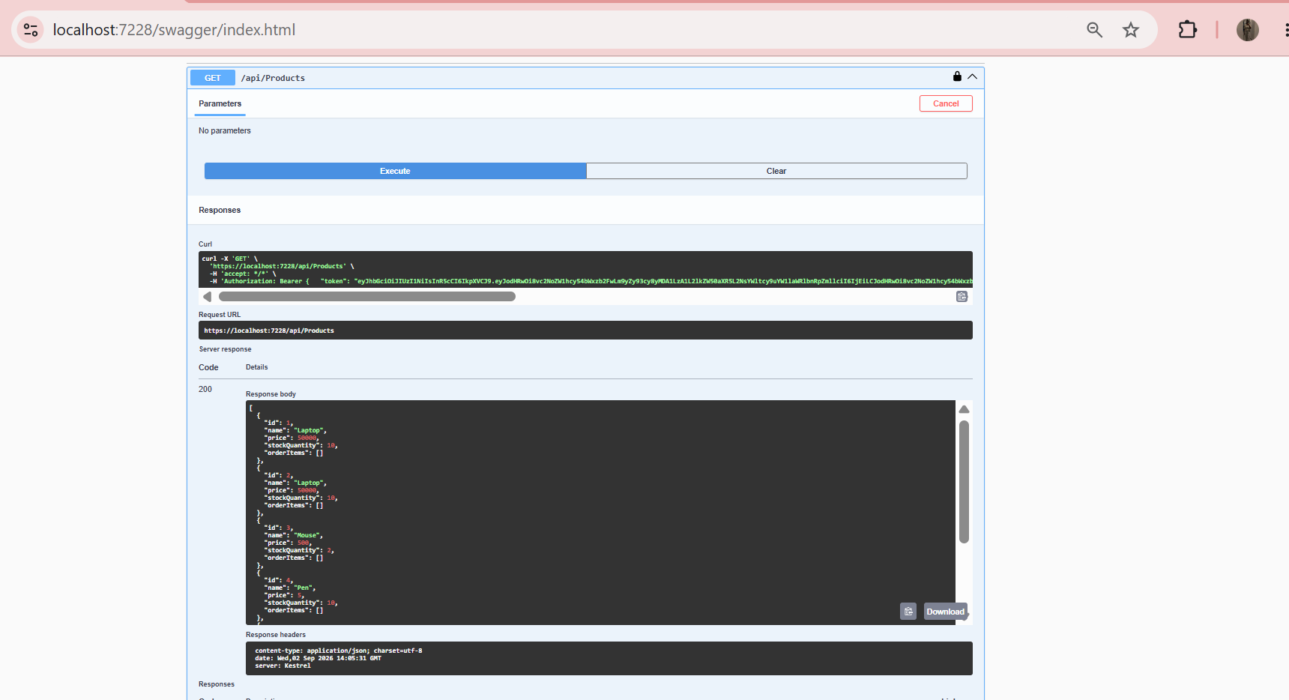

3.3 Get Product by ID
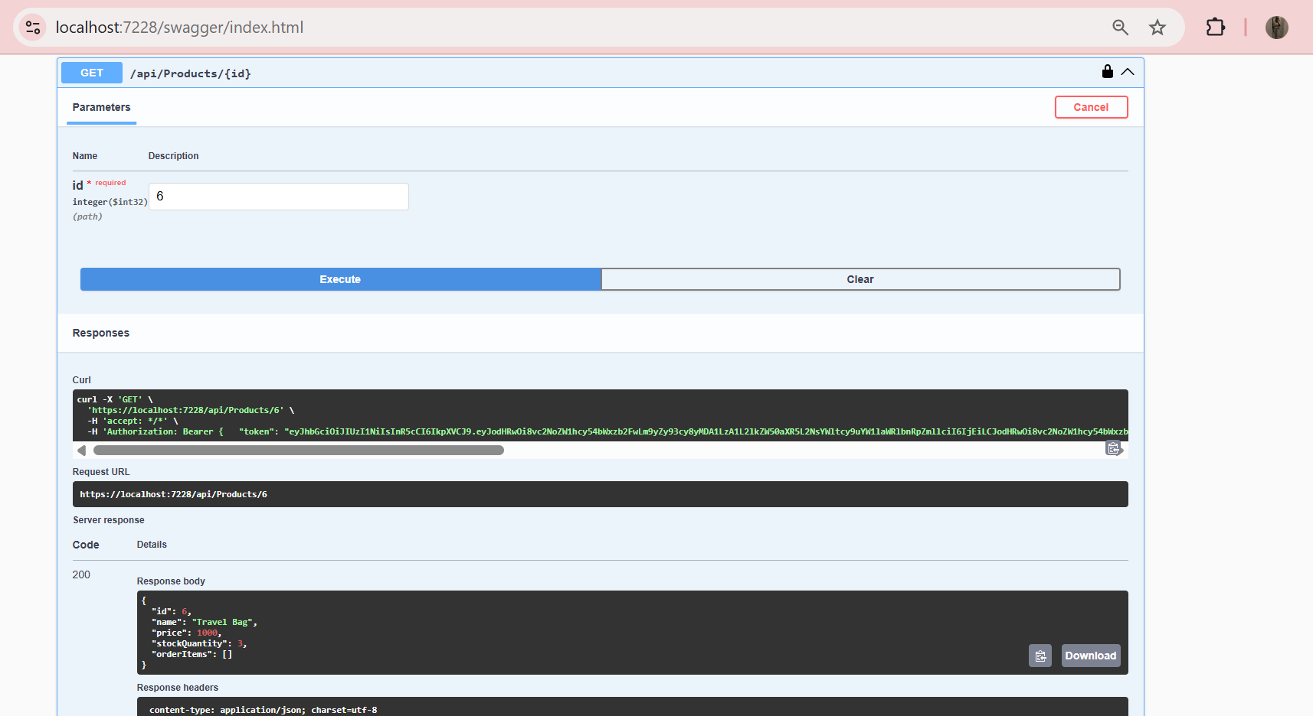

3.4 Update Product
Sample Request Body:

{
"id": 6,
"name": "Travel Bag",
"price": 1500,

}

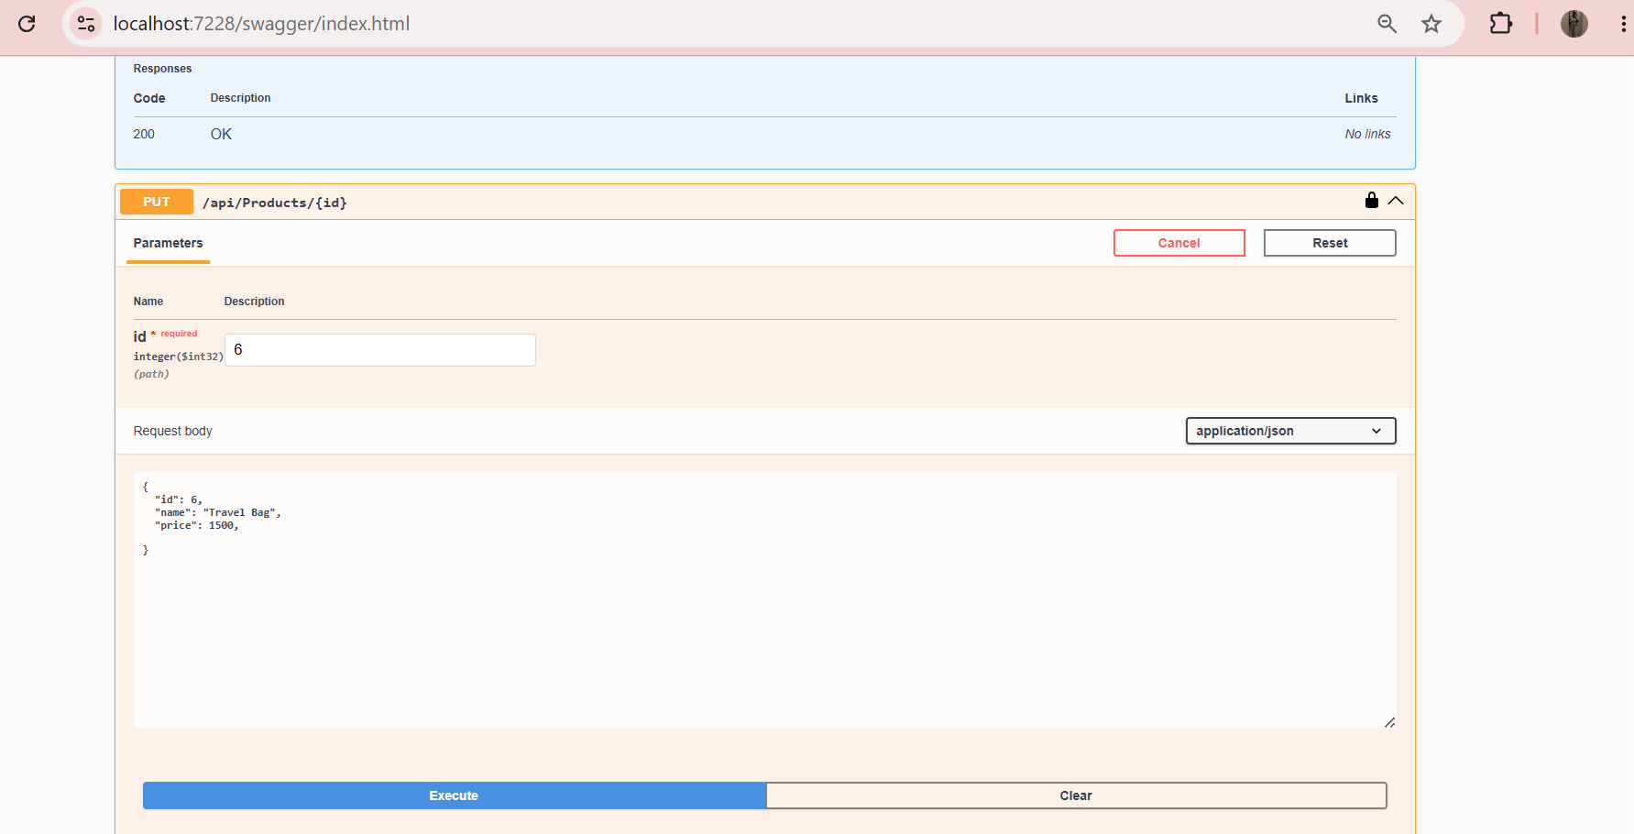

3.5 Delete Product
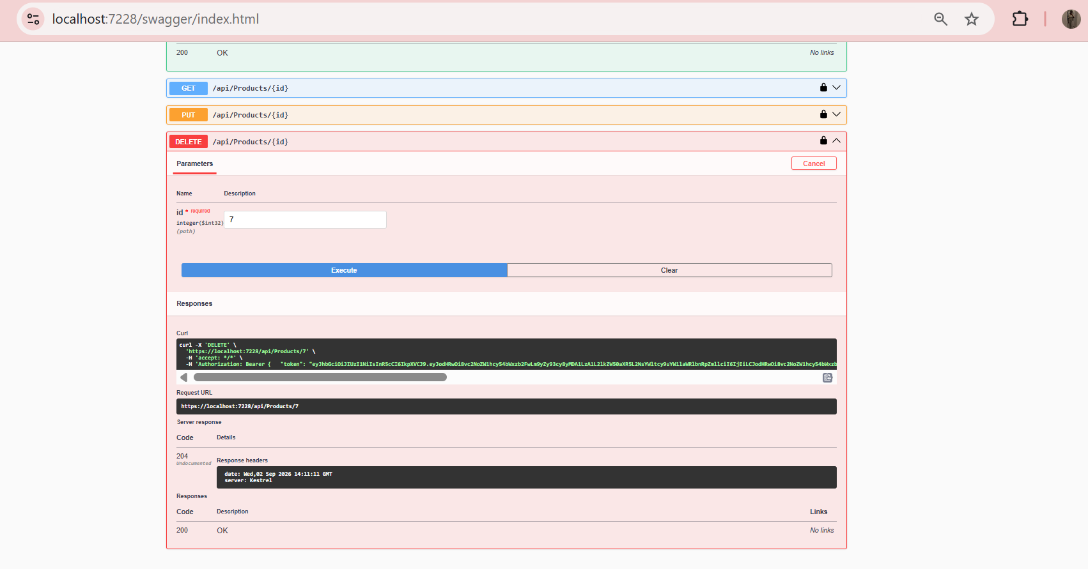

3.6 Product Database Result

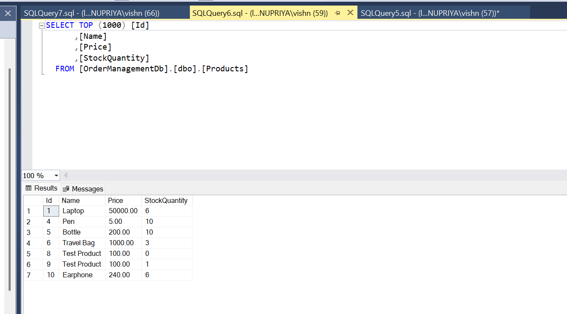

4. Order Management

4.1 Create Order
Sample Request Body:
[
{
"productId": 1,
"quantity": 2
}
]

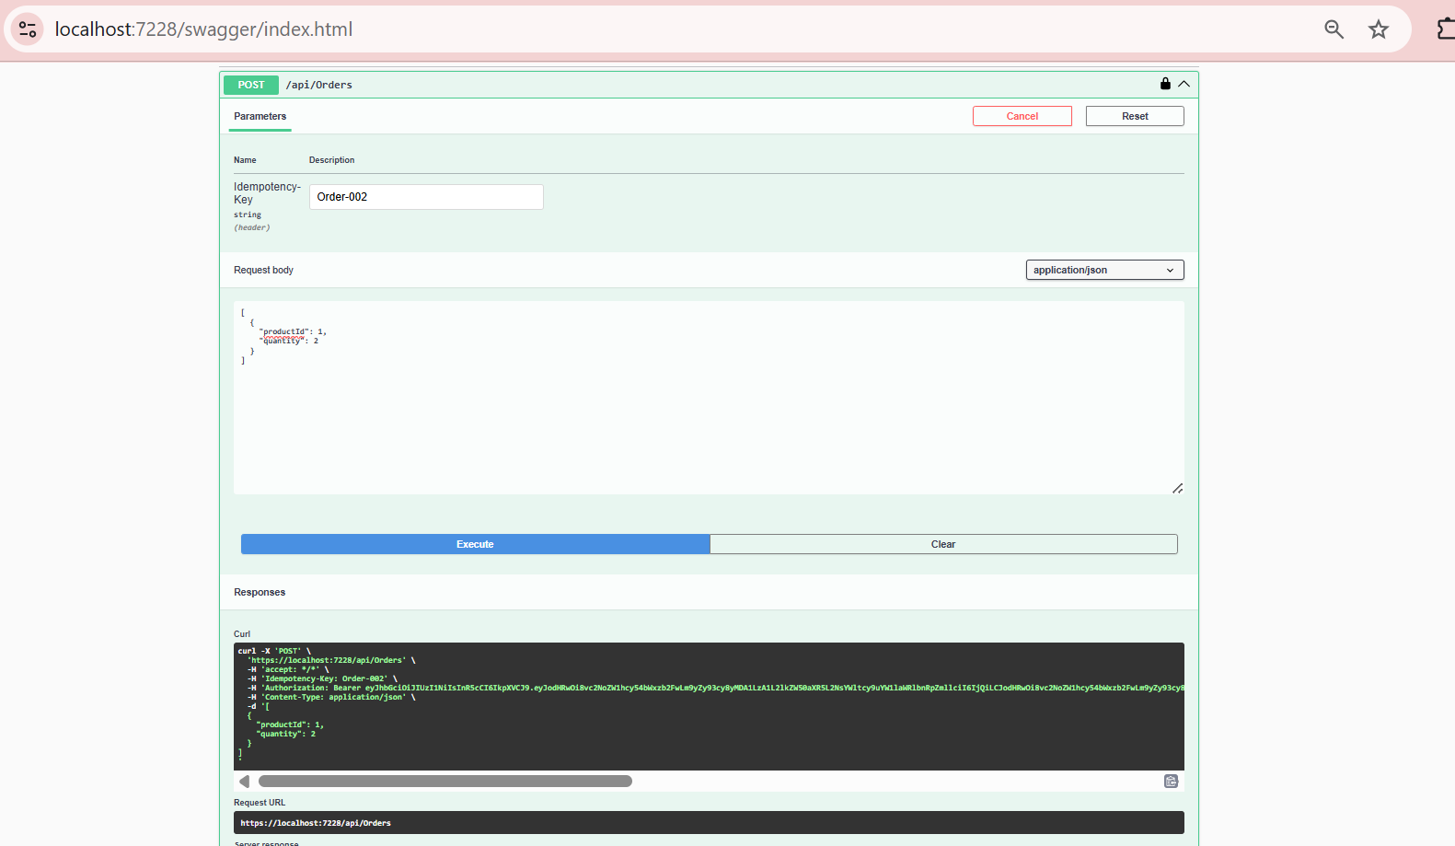
Response:
{
"message": "Order created successfully.",
"orderId": 2,
"userId": 4,
"totalAmount": 100000,
"status": "Confirmed"
}

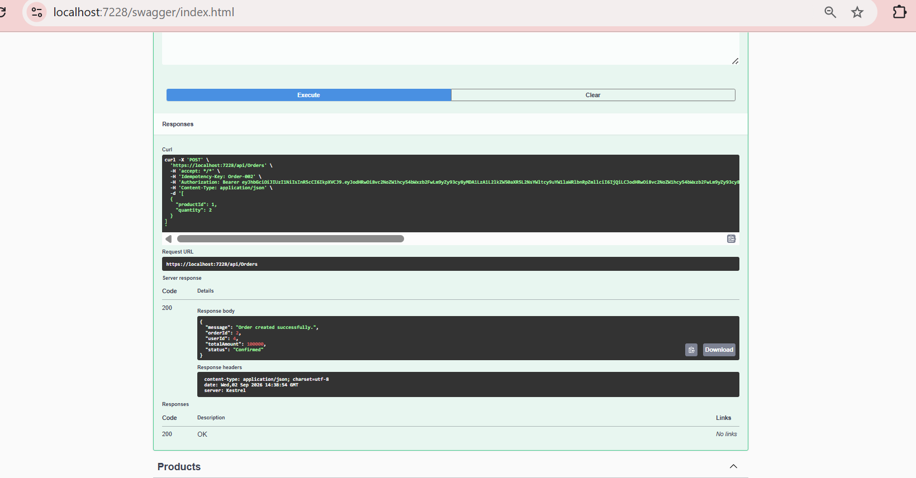

4.2 Duplicate Order Validation
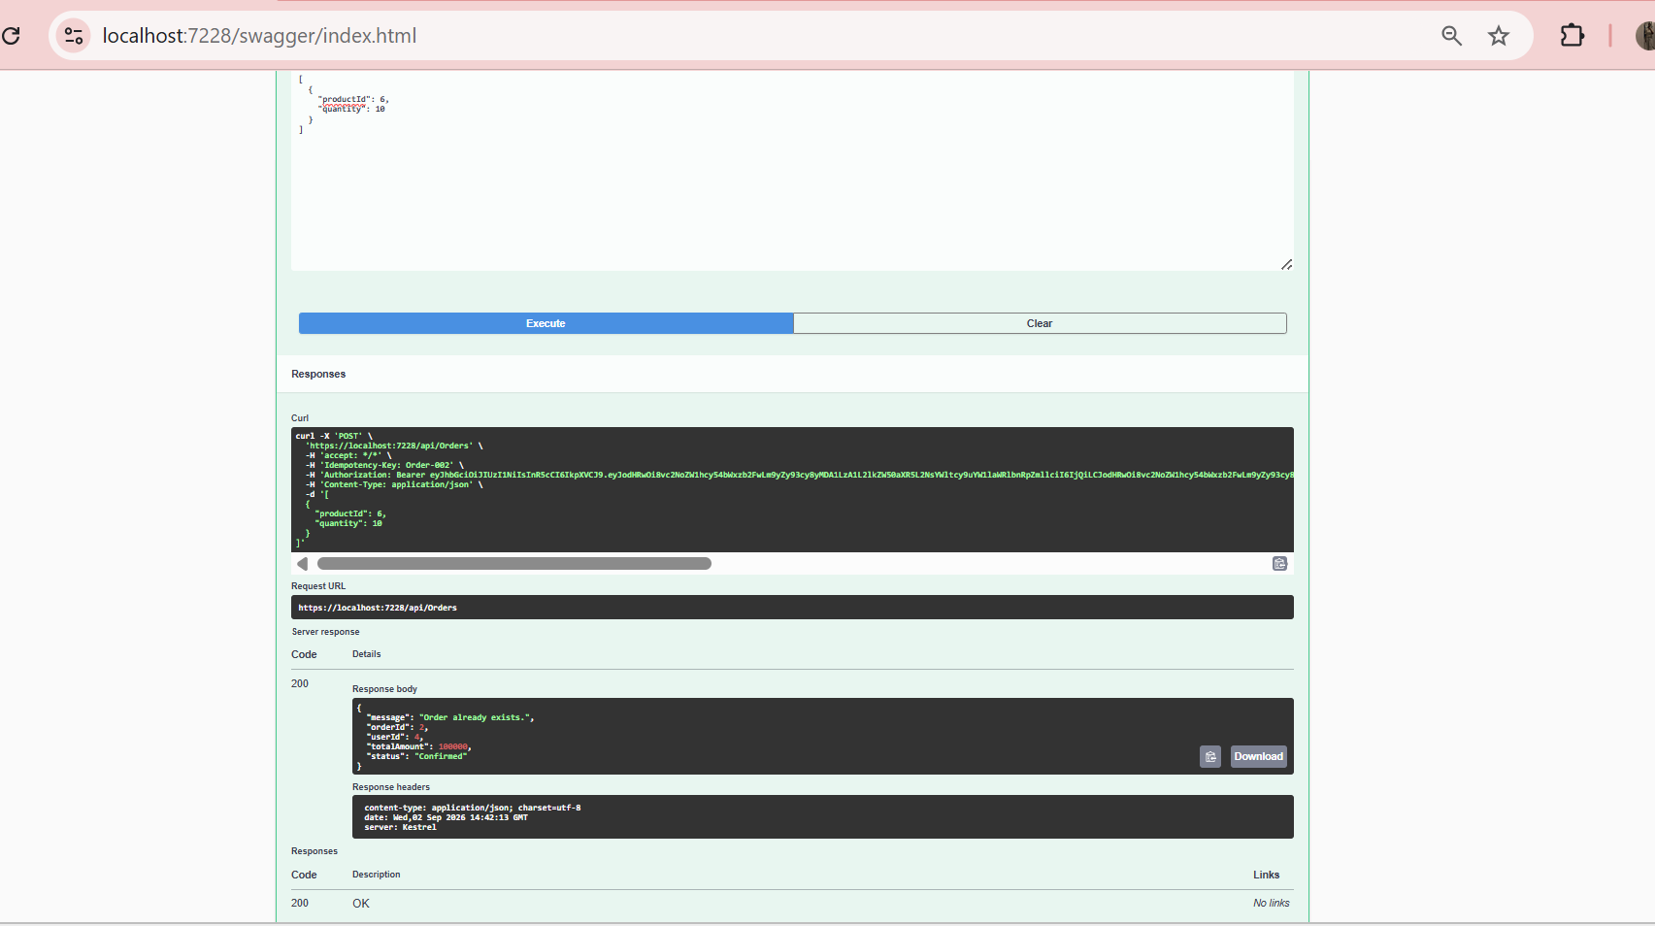

4.3 Insufficient Inventory Validation
Sample Response:
{
"message": "Insufficient stock for Travel Bag."
}
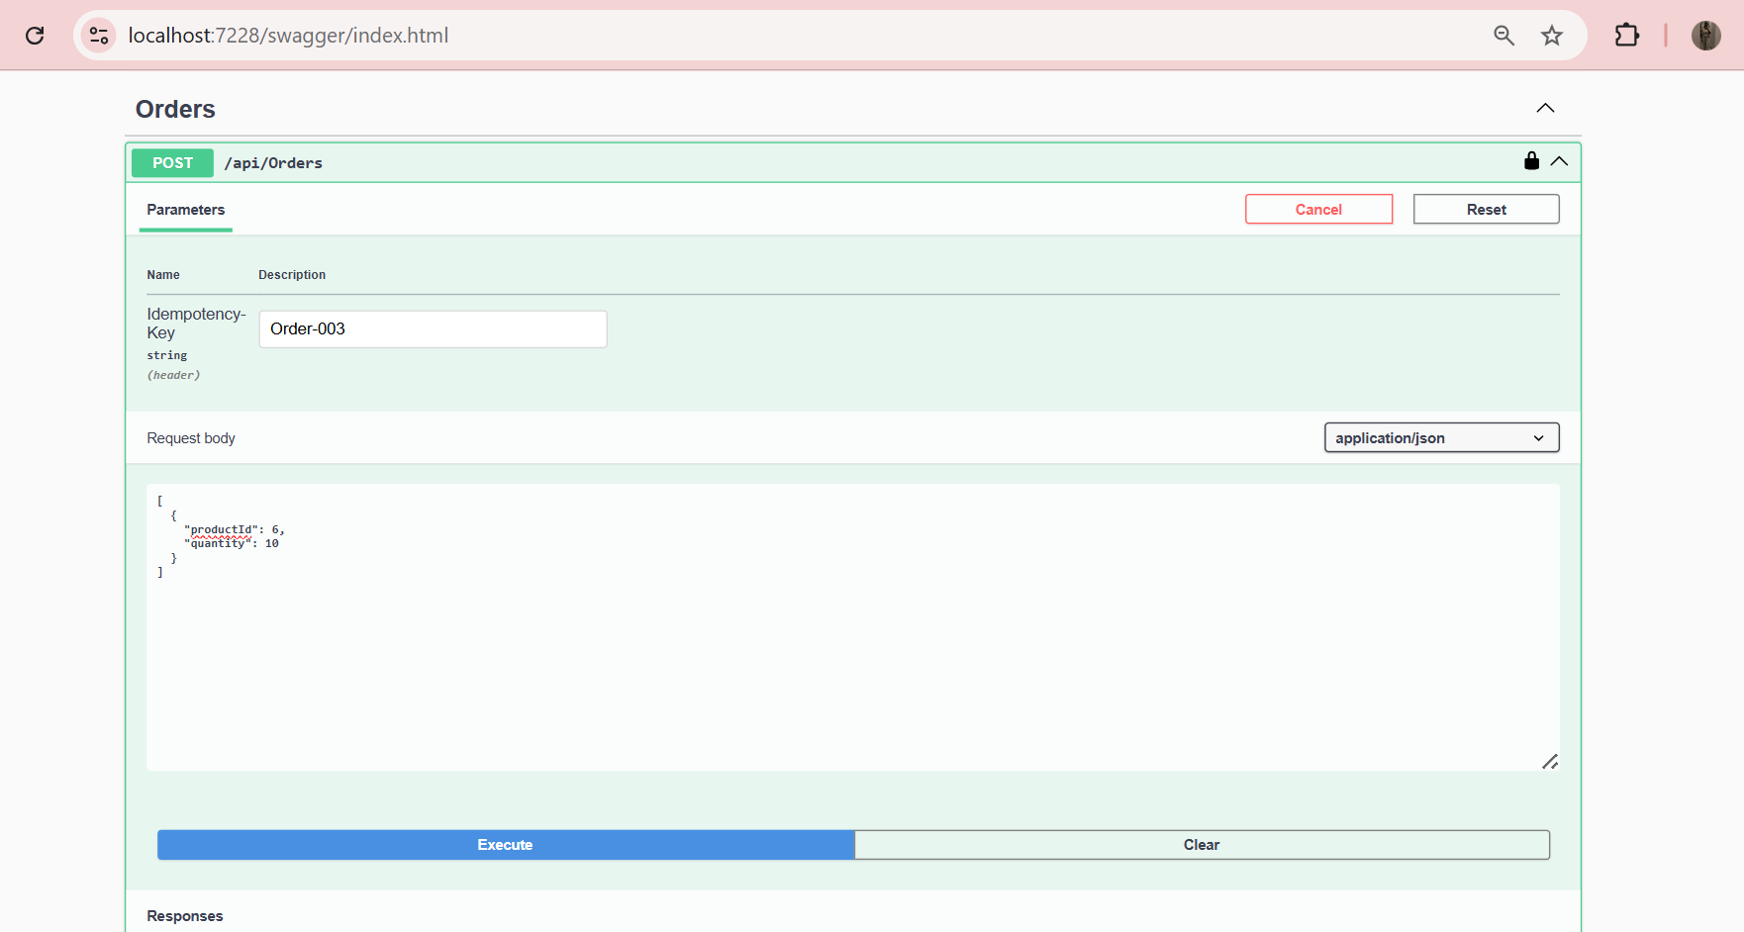

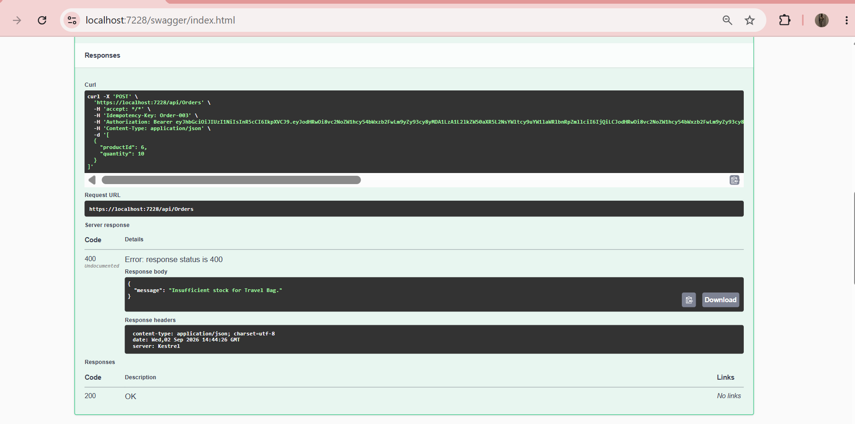

4.4 Concurrency Protection
{
"message": "Insufficient stock for Test Product."
}

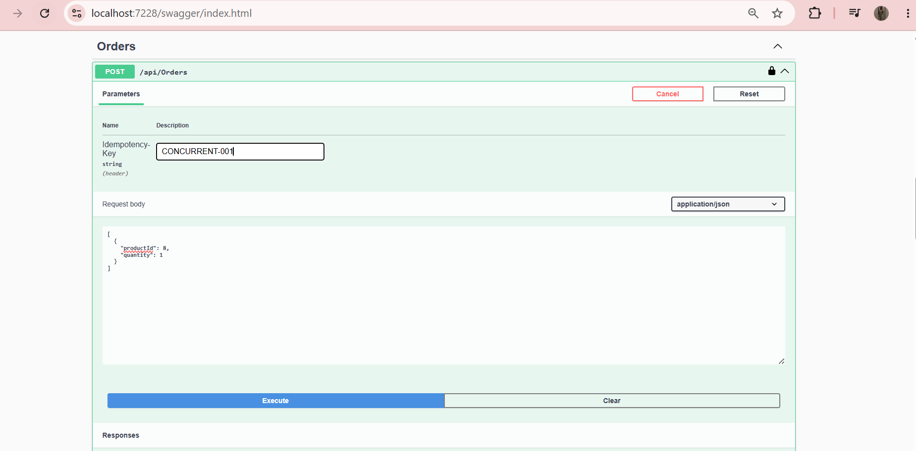

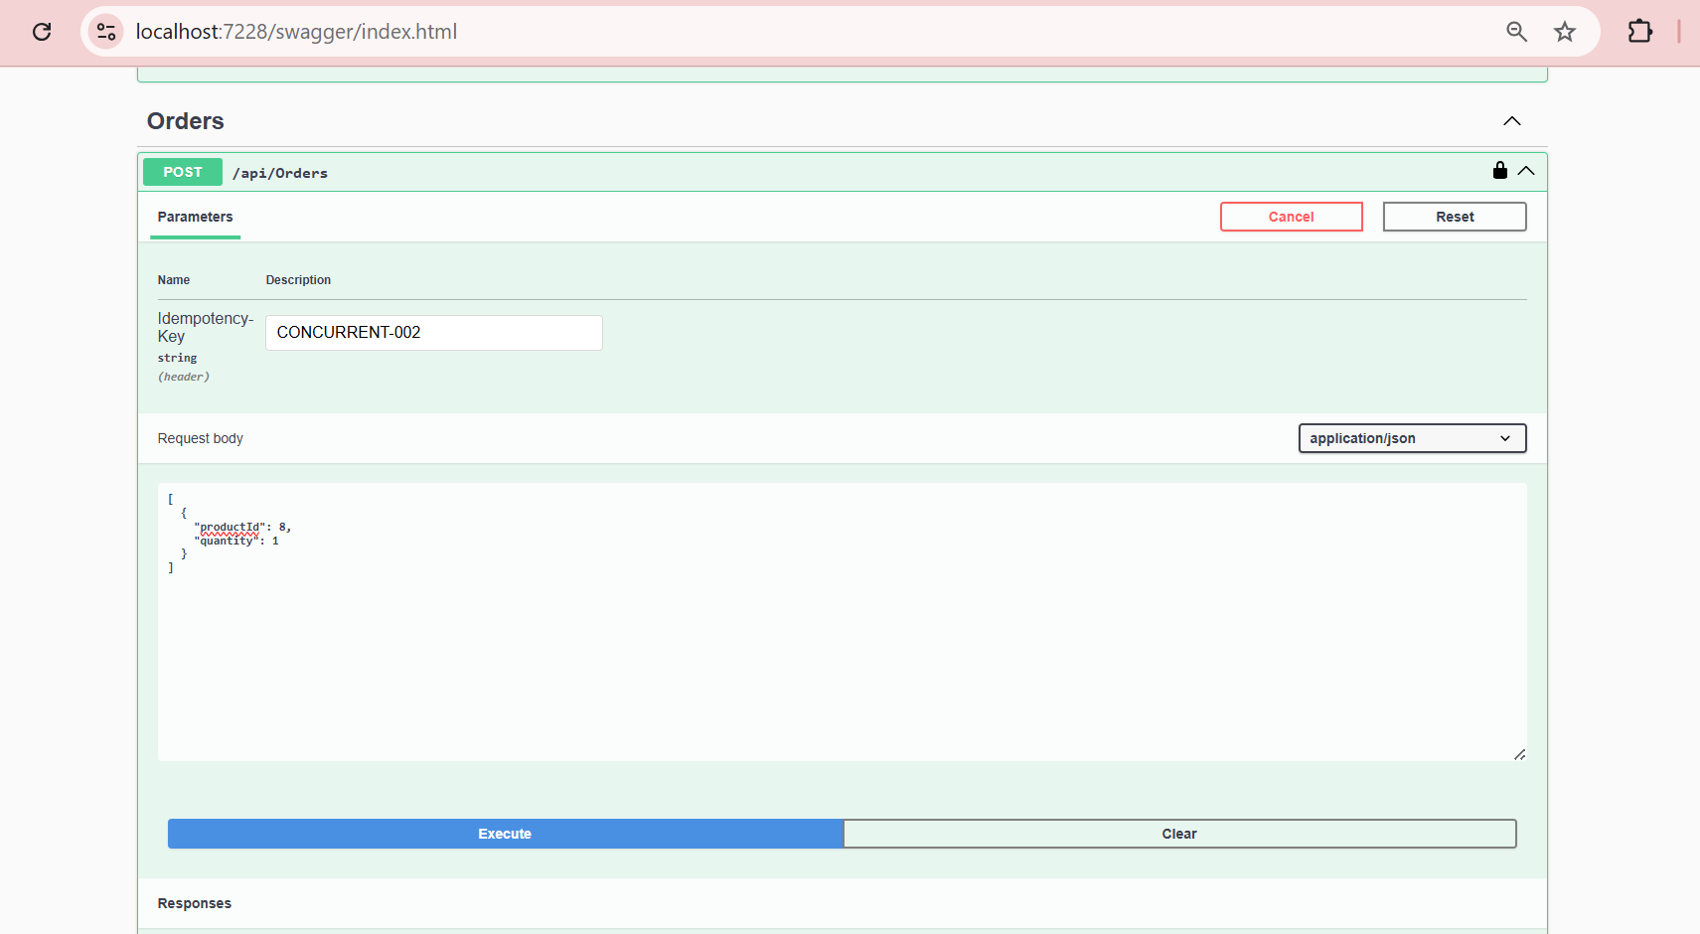

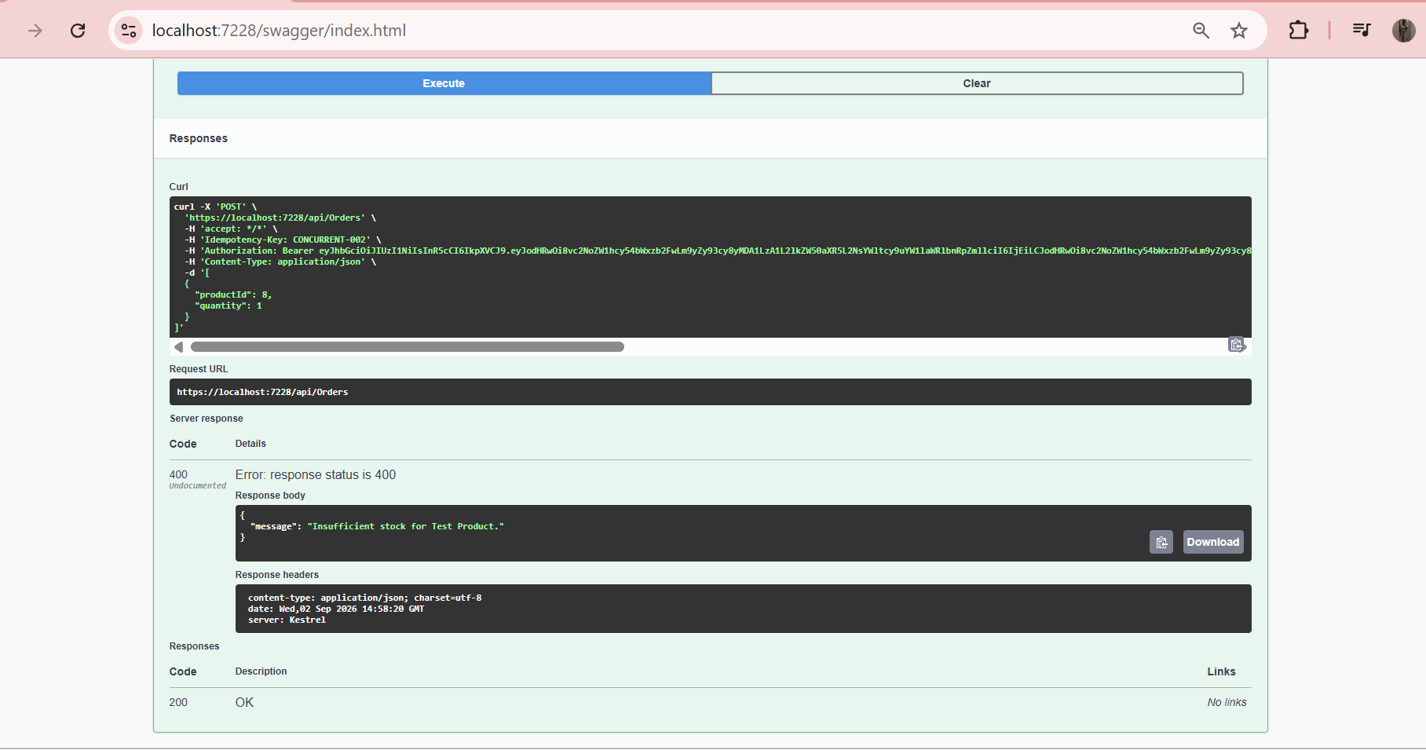

5. Database
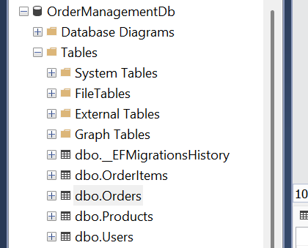

5.1 Product Database Records
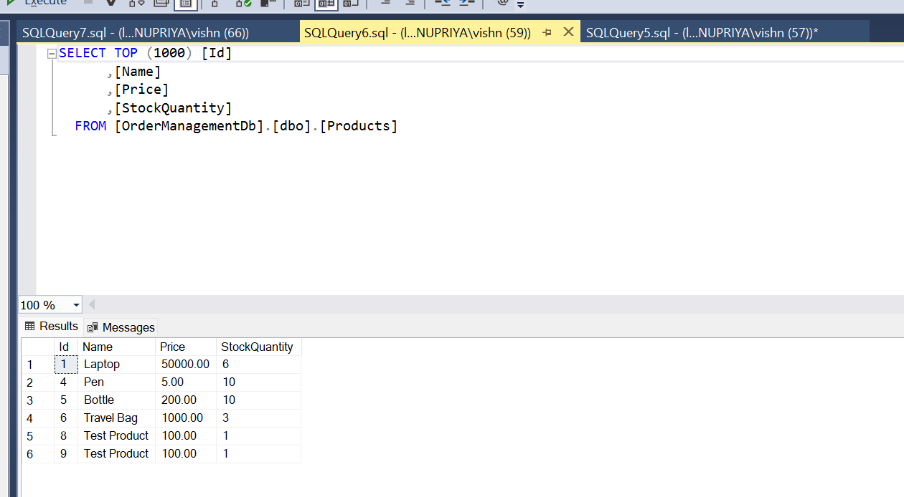

5.2 Order Database Records
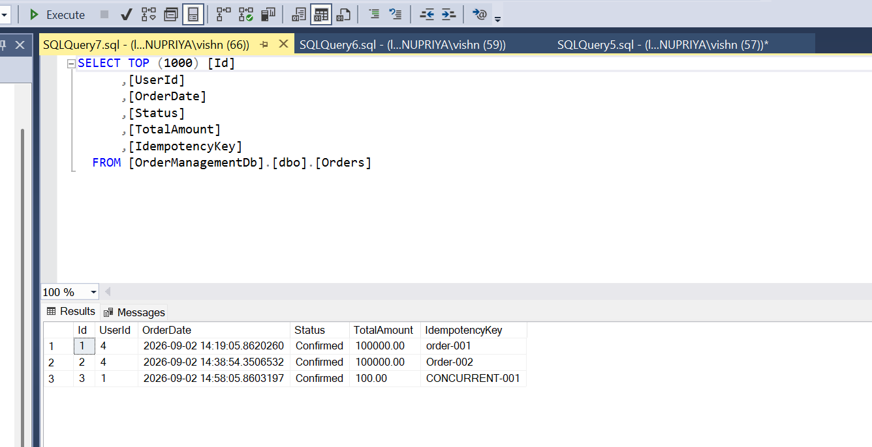

5.3 User Database Records
